Living Hope High School

**P. O. Box 2376**

**Bungoma,**

**Kenya-50200**

**Email: marilynkuhl59@gmail.com**

**info@livinghopehighschool.org**

**website:** [**www.livinghopehighschool.org**](http://www.livinghopehighschool.org)

***March /April 2019***

**The Secret Weapon**

**Living Hope** is facing some challenges. I know the Lord will move hearts. The students and faculty are pulling out their SECRET WEAPON, which is communal PRAYER! There are 13 form one students who need sponsors. The school can’t continue to sponsor them financially, without a sponsor. Living Hope has been using school funds to feed, clothe, bedding, shoes, and school supplies since January. This has been putting a huge strain on our meager budget. Loving Christians have always come through for the School.

The cost to sponsor a child is $110 a month. It includes, housing at the school, 3 meals, books, medical care and more. I first thank all of those who have or who are sponsoring a student. It has been such a blessing to the students, giving them Hope and Dignity. Their lives are challenging as they live in poverty, broken homes, on the streets and more. The students don’t have programs and ministries to help them like we do in the U.S. You can read about Living Hope High School, its history and how far it has come on the website <http://www.livinghopehighschool.org/Sponsor.html> **.** The students and their profiles can also be found on the website.

Could you, your church, or a church group afford to help?

I think so! Let’s break it down a little for sponsoring by groups choirs, UMW’s, youth groups, Sunday school classes.

Seven People- $16.00

Eight People- $13.75

Nine People- $12.50

Ten People- $11.00

**If**…………..

Two people sponsor - $55 a month

Three People-$37.00

Four People- 27.50

Five People-$22.00

Six People-$18.50

Sponsorship is a 4 year commitment to get the form one students through high school. If you would like to sponsor a student you can contact: Sandy Binotto, Mission Team Coordinator 1-304-839-1505, for a packet/information and 2020 Mission to Kenya [yashe4jc@hotmail.com](mailto:yashe4jc@hotmail.com)

or Helen Markwell – US coordinator [helenum@spruceknob.net](mailto:helenum@spruceknob.net) 1-304-567-2254

***Prayers needed for the following:***

* For student sponsorships
* Marilyn’s health –has Malaria again
* For students taking exams
* Mum Marilyn’s

Trip to US June 1

* Future Mission Team

Form One Students Needing Sponsoring

These are just a few of the 13 who need sponsors.

Asaph Wanjala- Hello! My name is Asaph Tunga Wanjala and I am 14 years old. I am the fourth born of eight children in my family. I live with my mom Elizabeth and my father Joseph.

Throughout my schooling I have always wanted to be a top performer. I was making my way through my primary education when my Aunt, who was also my sponsor, had to move out of Kenya due to the ban on plastic bags. Unfortunately, she made her income on the sale of plastic bags and when the country banned them, she no longer had a job. So after she left, I had to move back in with my family and went over two weeks without going to school. A few days later, the director of Milo Central Academy took me in and allowed me to be a candidate for their school.

I was quickly welcomed into this new school and soon voted by my peers as a School President and the Clubs and Societies Chairperson. I was very excited and went on to do well on my exiting exams to prepare for high school.

One of my favorite hobbies is drama. Throughout my schooling I have been top performer and also was awarded a certificate of participation at the national level. This allowed me to travel outside of my home county of Bungoma for the first time.

I pray that I will get a sponsor to help me through my secondary education here at Living Hope High School. This will give me the opportunity to advance and continue my studies in mechanical engineering.

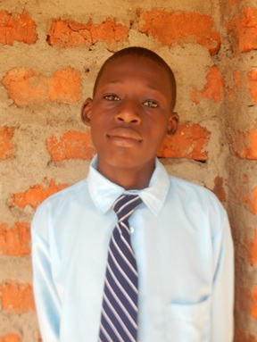

Jane Nafula Sifuna Hi! My name is Jane Sifuna. I was born on December 1st, 2003 and I have two brothers and 1 sister. I started my schooling in 2008 by attending Thompson Falls Academy which is located in Nakuru County and Naviasha sub-county. I attended there for three years and later moved in with my grandmother who lives in Kisii County. I continued my education Great Hope Academy. After my parents separated and they were no longer able to support me financially, I was transferred to a public school called Nyabogoye Primary School. Unfortunately, in 2014, my father passed away and left my siblings and I behind.

My siblings and I were blessed to be able to receive a free sponsorship from the Sara Davis Academy where we were able to attend together. During that period, I was able to complete my primary education. I am now blessed to be attending Living Hope High School.

One of the many reasons I love attending Living Hope High School is the administration and the education that I am receiving here. The friends that I have made here are amazing and I can’t wait to go through all four years of my high school education here. One of the many benefits of this school, is their resources, such as their library that I am able to take advantage of. When I am not in class or reading for leisure you can find me working on my art skills.

I want to pursue a career in medicine and pray that God will help provide a sponsor to allow me to complete the education part of my journey. I thank God for all who have sponsored this school in the past and those who continue to keep Living Hope High School in their prayers.

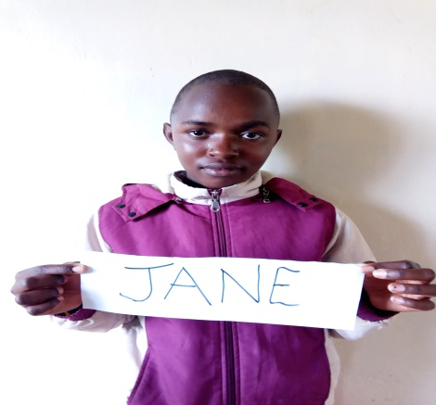

Ian Nyongesa Wekesa-Hello! My name is Ian Nyongesa Wekesa and I am 13 years old. I am the youngest of 8 children. I currently live with my grandmother, who has 5 children of her own to worry about.

Growing up it has been difficult for our family. My grandmother is the worker of the household and she spends her time earning money by farming. I have always helped my grandmother on her farm and even at one point as a young man had my own job. I used to raise chickens and rabbits but had to sell them off so I could focus on supporting my family by working alongside of my grandmother.

One of my favorite activities is playing sports, especially football. I look forward to playing alongside of my new classmates and friends here at Living Hope High School.

It is through this school that I hope to build my Christian faith stronger in. I look forward to spreading the word of God and ministering to others who are lost and do not know the good news of Jesus Christ. I hope to learn more about God and am also looking forward to all of the other course work here at school, as all of them are my favorites.

My prayer is that I find a sponsor to help me through this next step of my educational journey. I hope that they will help me obtain the best possible outcome for my future as I hope to study to become a lawyer. May God bless you all as I hope that soon I will have a sponsor.

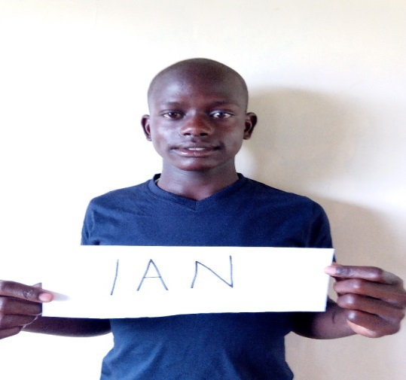

**Two Mission Volunteers Visit Living Hope in February**

Pam Francis and Connie Damon seasoned mission volunteers once again traveled to Living Hope to teach first aid and administer vaccines. While there they visited homes of some students and had lunch with past graduates of Living Hope. Their visit was very productive and enjoyable. The students learn many things from the volunteers who come to use their gifts and talents. Thanks so much Connie and Pam. You are making us healthier!!

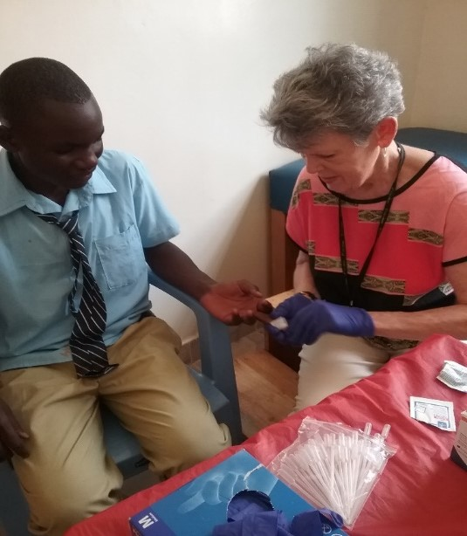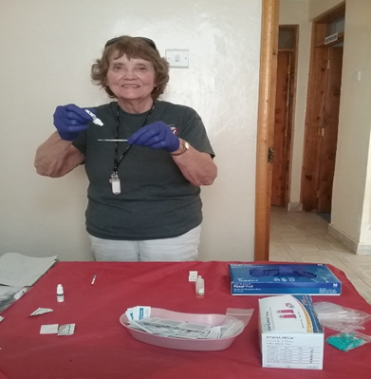

**April Volunteers To Living Hope**

On the First of April, 4 Volunteers from Virginia, David and Roseann Rhinehart and Bruce Goad and Gail Cox, traveled to Living Hope to do Vacation Bible School for the community children. The students of Living Hope helped by interpreting and teaching the classes. It was a great blessing for the community and LHHS students. We had almost 100 elementary students from the community. Many more wanted to come, but just didn’t have room or enough supplies. I think we have started something, something GREAT!!! It was a WOW! Thanks to the Virginian volunteers.

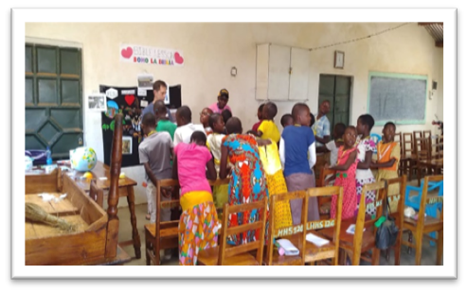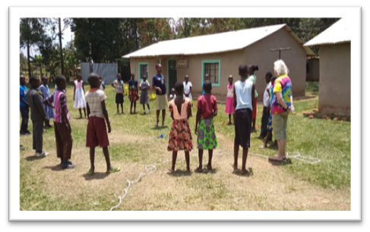

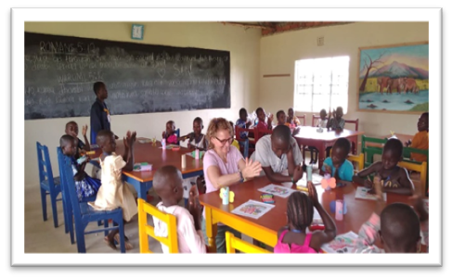

**Missions and Miracles**

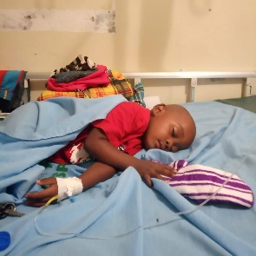

Miracles seem to always happen on mission journeys. One happened this past year, while on a team at Living Hope in January 2019, one happened. Evans, who is the driver for Living Hope High School, has a little son, John Wesley. He was sick with a fever and very lethargic. Evans took him to the hospital in our car and he was diagnosed with Malaria. Even with medical care, he didn’t seem to be getting better. Several team members went to the hospital and prayed over him. When you are small and malaria hits you, you get very sick. We had calls from Evans back and forth to the school as to how he was. The last call was little 3 year old, John Wesley was going into a coma and the hospital staff weren’t sure if he would live.

So again, the Secret Weapon was put into action because of his worsening condition. We went to work praying at when we got the call. Everything and everyone stopped immediately and began praying out loud. Our team gathered to pray as did the whole school. Five different languages were being spoken. The affect was a loud roaring sound. After lifting our fervent prayers up to the Lord, we got a call that his fever had broken and he sat up. Soon he was drinking and eating a little food. It was exactly at 3:47pm when we started praying and come to find out this is when he made the turn for the good. We sang out Halleluiah’s and praised the Lord for answering our prayers.

A good movie to watch is ***Mary and Martha*** with Hilary Swank which came out in 2013 about Malaria and its effects.

**The prayer of a righteous person is powerful and effective. (James 5:16)** [**The Bible**](https://www.bing.com/search?q=Bible&filters=sid%3a45780efe-b776-681a-2f6b-7d3635fe12f0&form=ENTLNK) **has a lot to say about prayer. After all, it’s the way we communicate with our Lord. And all of it promises that God hears and answers prayers, especially those offered by two or more in agreement (Matt. 18:19)**

**The Pavilion**

The new Pavilion is finished and being use by the School. It is such a wonderful and beautiful addition. It provides a place for the students to gather, to study, share and eat, and pray on nice days. The school once again thanks all of the donors who so generously gave to this project. We also give a big thanks for the students and others who helped make this a dream come true. Each addition is a blessing and used as a ministry to help the students and the community. The school praises the Lord for the buildings and additions that have taken place in the past years.

