Living Hope High School

**P. O. Box 2376**

**Bungoma-50200 Kenya**

**Email:** [**marilynkuhl59@gmail.com**](mailto:marilynkuhl59@gmail.com)

**info@livinghopehighschool.org**

**Website: www.livinghopehighschool.org**

*September 2018 Newsle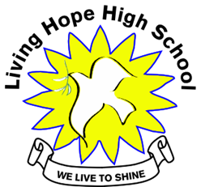tter*

**What Does It Take to Run A School in Africa? - Sandy Binotto**

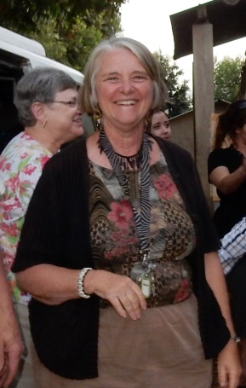

I wanted to share with those who support Living Hope High School, just what it takes to run and direct this project in Africa. It takes prayer, faith, courage, and perseverance. Also you have to be flexible and adjustable. It takes doing without the luxuries we have in America. Many times there is no electricity or the generator breaks down and then water has to be carried by the bucket full up through the fields from the stream for its daily purposes. When things get tough they pull out the SECRET WEAPON prayer, where all the school gathers together to pray. It doesn’t matter if it is the middle of the night.

Then there are the teachers and staff who need to be paid for their services. There are wood choppers and cooks who prepare meals for the 86 students. Then they have the principal, van driver, office manager, and the person who takes care of the livestock! Persons are hired to maintain the buildings and ladies to re-mud the cottages on an as needed basis. One of the most important members of the team is the school nurse. She is there to help mend and heal those in need.

And let us not forget those in the US who help whole heartedly. They work diligently to get sponsors for the kids, write the newsletters, send out correspondences for Living Hope, speak at churches when needed, and maintain the website. Then there is the accountant, LaVonne Hammett, who does a wonderful job of keeping the finances in order.

At Living Hope, they have the help of past student graduates who come back when they can and on holidays, to volunteer their skills. Many times we build projects, but only when we have donations to cover the costs. Since 2014 many volunteers have stepped foot on the grounds and fell in love with the students and the school. Many return year after year to re-connect, teach, build, and provide love to the students. They get back much more than they give. Many of the students have been through things we couldn’t even imagine. They love LHHS. It is a love that is hard to explain. It is all because a woman, Mum Marilyn heard the call of God that moved her heart into action. It is also because of you, those who sponsor or sponsored a student, volunteer or donate to the school. All of you are a blessing and will be blessed by the Lord for being connected to this school and its students, its teachers and staff! May we all continue to reach out with love and compassion as Christ called us to keep this ministry going.

**A Heart of thanks from Immaculate after her mothers passing.**

Thank you to all the people that have helped me through this difficult time. Thank you so much for your support for me and my family. Because of the support from all of you, we have made it. We are all well and getting use to our new life.

My older brother, Alex, is living with my aunt and uncle in Kanduyi. He is in P7 and is getting ready to take his test at the end of the year. He is first in his class. With some of the money that you sent, I paid for him to get a new uniform, a backpack and some school supplies. He was very thankful.

My next brother is little Sam. He is ten years old and is number 5 in his class. He loves to hunt birds, which we eat. He was very sad when our mother passed. He moved in with my Grandparents and started school at the local school. I bought him two new uniforms and he was so proud. Right before our mom passed, he was circumcised so he was not allowed to attend the funeral. That was sad. But thanks to you his school fees are paid and he is all set to join Nzoia Primary School. It is a public boarding school with a good reputation. I am sure he will do well because of your support. Thank you, *Immaculate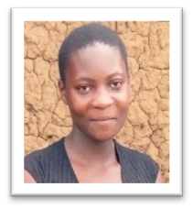*

***Cooks Get New Uniforms***

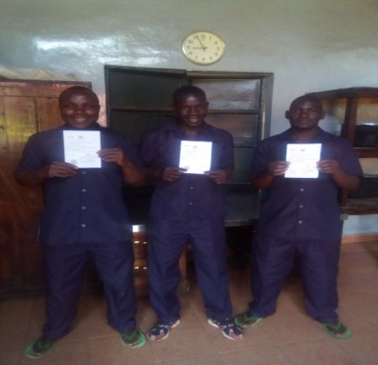

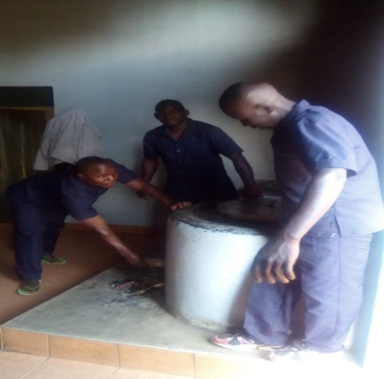

Living Hope High School cooks work long hours to make sure the students get some good meals. They received new uniforms and certificates for their work. Yes, Kenya has some health requirements for their kitchens. A volunteer team last year remodeled the kitchen with tiles and cabinets. Let’s just say we all are very happy for the update!

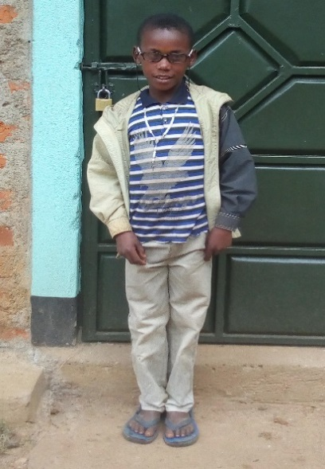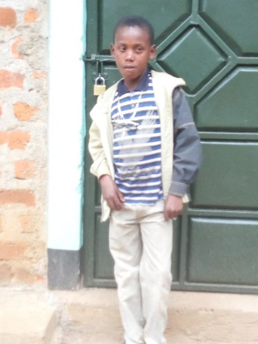

**The Little Professor!-Community Service Project**

This is Meshack Kundu. He is a little boy that came to our eye clinic last month. He is 12 years old, but very small. He was born with one eye severely crossed. His mother has taken him to many eye doctors with no hope. I took him to see my friend from New Zealand, who is an eye surgeon. They recommended him to a pediatric optometrist in Weybuye. He is one of two in all of Kenya. The school paid for him to get special glasses. Meshack came yesterday and we were amazed to see the improvement in just two months. What a miracle! His grades have improved and he wears his glasses all the time. The kids call him "the professor". Thanks to Connie Damon and all the church members for helping with the eye clinic. The kids that got glasses are very happy and can see much better now. Praise the Lord!

**A Dream Come True!**

Naphtal Sikuku, a Living Hope graduate, was blessed to spend 4 months in the United States. It was a dream come true for him. He was able to visit many volunteers who had visited and worked at Living Hope. He was able to share his story at a few churches. His home base was with his host, Gail Cox and her family, in Berryville, Va. While in the states he worked at a UMC Camp in Ohio for disabled youth and adults. After camp he went on a tour to many places. He will be writing a story of his visit for the next newsletter. He has now returned home back to Kenya and school with many stories to share!

Naphtal finally tries a Shrimp! 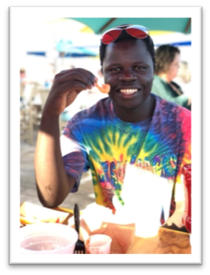

Gail Cox, Naphtal’s US host for the 2018 Summer.

Naphtal’s gift he got in the US!

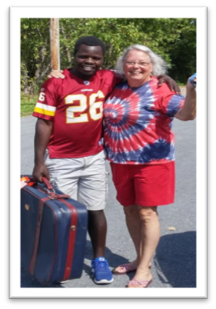 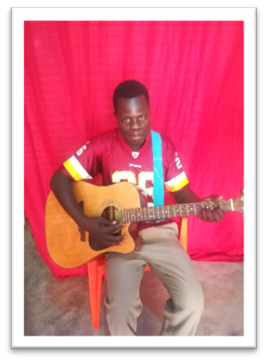

**2019 Mission Team**

January 8-24, 2019, a group of ten volunteers (8 of which are from the WV Conference) will be making a journey to Living Hope High School in Bungoma, Kenya. For several, it will be a return trip. For the others a brand new adventure. This year the team will be building a pavilion where the students will be able to study, share and enjoy time spent in conversation. It will be an outdoor gathering place. In the mornings, there will be construction and classes for the girls. In the afternoons, the team will hold workshops to teach sewing, music, art, cooking and computer technology. The team will be using their skills and talents to do puppetry and invite the community to have fun and teach the students about how to do their own puppet shows. Many of the skills taught will help them as they continue their lives after graduating. The evenings will be comprised of bible study, games, movie or talent shows, and worship. The students look forward to incoming teams. The students mostly work hard studying and keeping the school going. The volunteer teams bring some fun activities for them, that they have never seen or done before. We ask that you keep the team in your prayers as they prepare their mind, bodies and hearts for the trip. If you would like to make a donation for materials needed for the Pavilion, you can send them to the Riverton UMC, P.O. Box 23, Riverton, WV, 26814. Please put “Pavilion Project” in the memo line. This would be a great year-end tax deduction.

***College Fund in Desperate Need***

All of you that have contributed to the college fund in the past are to have a special thank you and a star in your crown. This funding of college students was never in our thoughts as we started the school. We have found that without a college education, even in Africa, the competition is too high to find a self-sustaining job.

This year is the first year that our high school graduates will graduate from college with their 4 year degree. We currently have 67 LHHS graduates in college. The majority of them (about 15) are struggling their way through this next level of education. They pray daily about being concerned on how they are going to be able to finish the upcoming semester of college, both financially and physically.

Sometimes they are using their food money on their tuitions. A few have sold livestock and land to come up with enough money to survive. Some are even letting their health fail them so they can pay their tuitions and rents. These students are truly dedicated to their faith in God and their education. There are a few that are going to have to quit and come home as all financial avenues have been exhausted.

With so many successful high school graduates, our “college fund” is dwindling and soon will be drained. It is with a hopeful heart that after reading this, some of you may be moved to help these struggling college students financially.

If you are compelled and wish to donate to help Living Hope High School continue to be “fishers of men”, please send any donation to Living Hope High School PO Box 23 Riverton WV 26814. In the memo line on your check please note “COLLEGE FUND”.

Our accountant, Lavonne will send the monies to Living Hope so that Marilyn can divide the funds to those desperate students in need.

We thank you in advance for any donation you may be able to make. And as the year is coming to an end, remember your donations are tax deductible.

May God Bless you and continue to hold you in the palm of his hand

**Announcements, Announcements, Announcements!!!**

A Mission Team will be traveling to Living Hope January 8-24, 2019. Please pray for them for safe travels and good health during their trip. If anyone would like to donate to project materials please send them by **Dec 15** to Riverton UMC P.O. Box 23, Riverton, WV26814 memo line “Project Materials- January VIM Team”.

John 3:16 “Kwa maana jansi hii Mungu aliupena ulimwendgu, hata akamtoa Mwanawe pekee, ili kila mtu amwaminiye asipotee, bali awe na uzima wa milele.”

If you have any questions please contact-**Helen Markwell** - US coordinator

helenum@spruceknob.net

1-304-567-2254