Living Hope High School

**P. O. Box 2376**

**Bungoma,**

**Kenya-50200**

**Email:** [**marilynkuhl59@gmail.com**](mailto:marilynkuhl59@gmail.com)

**info@livinghopehighschool.org**

**Website: www.livinghopehighschool.org**



***November/December Newsletter 2018***

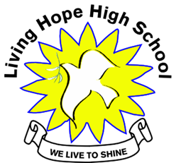**Being Thankful**

We just celebrated Thanksgiving. A time to be Thankful! Living Hope High School is thankful to so many. Here are some stories of being Thankful………

When these Methodist women get going, there is no stopping them! We collected from three different churches yesterday (St. Paul's UMC, Trinity UMC, 1st UMC Parsons). God stopped the rain so we could load and unload all of the stuff! As the kids back home in Kenya say "it was a WOW!"  We got a wonderful box of towels from Bill Grant, which will be packed into our welcome kits.  These welcome kits are for our new F1 freshman who arrive at school on Jan 3, 2019.  A lot of them will come with nothing, so this is a welcomed blessing.  We also received donations of baby clothes from the Mtn. Top Pregnancy Center and sandals from two families that are connected to the pregnancy center. Another great donation was several pairs of gym shoes. Trinity brought us so many homemade baby hats and booties. This picture shows Parsons (Dorothy Carr) and Trinity (Terry) ladies loading the car. Lastly, we received many large boxes of medical supplies donated by Ellen Kirby. Rev. Larry Anderson gave us upwards of 90 jackets and new uniform shirts for the students.   We are so thankful and blessed by these wonderful friends of Living Hope High School. They and the Lord have provided just what we need! God bless you all!

God is at work, Marilyn Uhl

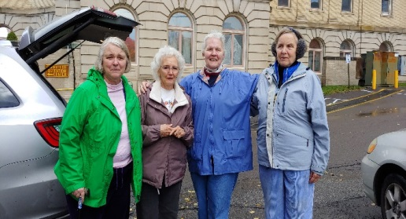

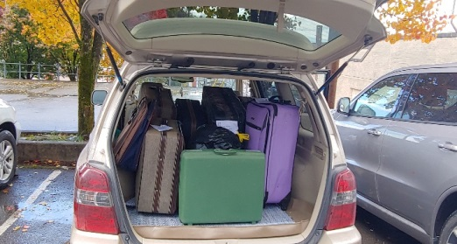

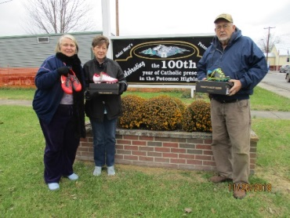Living Hope was surprised with a wonderful gift. We received 33 pairs of brand new soccer shoes from South Branch Valley Liquidators and St. Mary’s Catholic Church in Petersburg, West Virginia. This is the second time that Joyce and Bill Hudgins have partnered with St. Mary’s to help our soccer team. The first time was four years ago and the shoes that they donated have all been used and repaired many times. Living Hope High School in Bungoma, Kenya is proud to call Joyce, Bill, and St. Mary’s friends in Christ. Thank you for loving us. We will play soccer for the glory of God!

**A Letter of Thanks by Sharon Mukitangi**

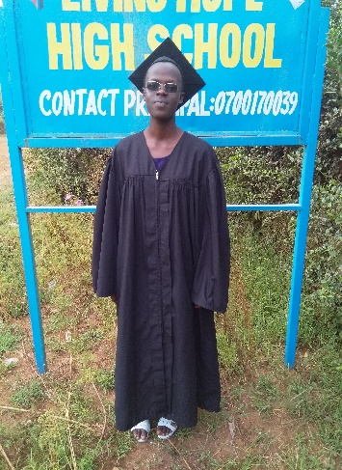Hello my beloved sponsors to my school, you people of integrity. I am so much humbled to write to you. You are so wonderful and great. You know I always just sit down and imagine how you people have foregone your needs and sacrificed the money for your luxurious lives just to send them to us so that it can cater for our needs and sponsor our education. I am so thankful for that,may the almighty thank you and I honor you so much.

*As you know, most of us were born in very poor background that even finishing primary education was just by God’s grace.* ***But it doesn’t mean that we were poor in mind, God blessed our minds with great thoughts to think big and plan for our lives, but the only problem we had was how to acquire education to help us pursue our dreams and be better people in the future and we were praying to God.*** *I personally believe in prayer as my* ***secret weapon*** *and I thank God because he heard my prayers and welcomed you into my life. I just want to say that the work in for God is never in vain.*

I just lack words to describe your great stewardship unto me and my other fellow students. I am sure God is so much pleased with you and I pray that he may give you long lives to live and test his blessings into your lives. May he bless the work of your hands and more so bless your children to live a good life.

You have finally made me to make up my mind that when God exalts me and helps me to pursue the goal of my dreams. I will also touch the lives of other poor and needy people by providing for education to them so that they can have a better future to live and help them realize who they are into this world. I will provide spiritual guidance to them and nurture their talents the way you have done for me.

I thank people a lot and treasure you. May the almighty God Bless you and Exalt You.

Sharon Mukitangif- this year’s graduate 2018

**Nurse Catherine Nelima**

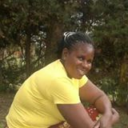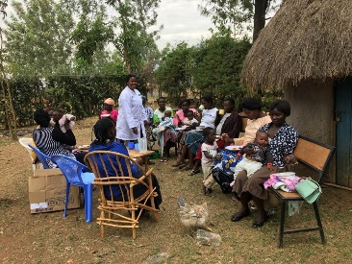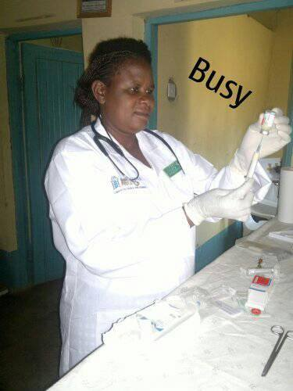

I met Catherine last year while on our mission to LHHS. We became friends instantly. She told me her life story. Soon our team was invited to her wedding and to her church. She is also a pastor. Her small church was so packed. Several team members visited with lots of singing and praising the Lord. Soon we were being lead down to the river to attend a baptism. It was quite the hike to walk there, and many were there to worship. It reminded me of the river where Moses, as a baby, was put in to be rescued.

The baptism was such an experience to be a part of. Her wedding was beautiful. It was a traditional Kenyan wedding that lasted quite a while with joy, singing and dancing. This was my first Kenyan wedding, and one that I will never forget. Catherine is a special woman who loves the Lord and takes such good care of women and children. Here is what she does at Living Hope High School and beyond- by Sandy B……. Catherine says….

**My** role at Living Hope High School is to take care of the sick students, diagnosis and give them treatment. I also guide, counsel, and offer youth friendly service to ensure that they enjoy good health and well-being while in school. For the H I V and Aids mothers and their babies, I offer an neonatal clinic to all pregnant women. I provide guidance, counseling, and testing. Then I give treatment to mothers for child transmission during pregnancy and after birth.

I pray that God may touch his people in America to help me with some money to pay for the clinic where am operating from. I pay $56.00 per month and buy drugs for the H I V and Aids mothers and their babies to prevent them from getting opportunistic infections, e.g. pneumonia, typhoid, malaria, anemia, and dermatitis. This is a challenge to me because sometimes I run short of the needed drugs. I also need maternity and children clothes. Many of them are poor and cannot afford to buy shoes or clothes.

Our mission team is taking baby clothes this year and some shoes (thanks to UMW).

If you would like to help Catherine you can send donations to Riverton UMC, P.O. Box 23, Riverton WV 26814 ear mark it for Nurse Catherine.

**Women’s Event Highlighted Connie Damon**

**LHHS Volunteer and Fund Raiser**

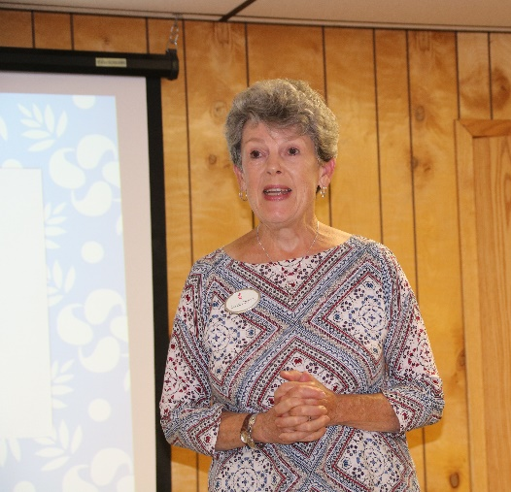On Saturday, October 13, First United Methodist Women of Keyser hosted their second annual Women’s Event with more than forty women in attendance. Entitled “Woven,” the focus of this year’s conference was how to weave a deeper relationship with God and how we respond to the people that God intentionally weaves into our lives to disciple us and for us to disciple. As women entered the fellowship hall, the theme was evident in Sarah Fletcher’s display of her loom and many woven pieces. The morning began with singing praises led by Debbie Ravenscroft and accompanied by Pastor Shirley Reed. Connie Damon from Jarrettown United Methodist Church near Philadelphia was the featured speaker. Her experiences include many summers of teaching Bible School to the Inuit children of the Arctic, and numerous mission trips to Bungoma, Kenya to teach and work at Living Hope High School. She shared insights into how our relationship with God is rooted in our prayer life. Her personal stories, including amazing answers to prayer, highlighted her presentation. There were many accounts of monetary or material needs for Living Hope that Connie was able to provide, not by incidental encounters, but with God-intended moments with exactly the right persons who could meet the particular needs. During a lunch of delicious soups and salads, participants engaged in a discussion of several relevant questions. In the afternoon they shared their responses with the large group and then enjoyed an activity for which a variety of door prizes were awarded. The afternoon session focused on Paul’s last words in his letter to Timothy to “kindle afresh the gift of God that is within you.” The women were encouraged to have willing hearts where willing means saying to God, “I’ll go where you want me to go; I’ll stay if you want me to stay; I’ll do what you want me to do; I’ll say what you want me to say; I’ll give what you want me to give. I am entirely yours; I will hold nothing back.” At the conclusion of the day, each participant made a commitment in writing of the changes they intended to implement in their lives and contributed that strip of a paper to a woven pattern. The event was coordinated by Karen Campbell and Debbie Seldomridge. Watch for our next event in the Fall of 2019.

**Stanley Kutiri**

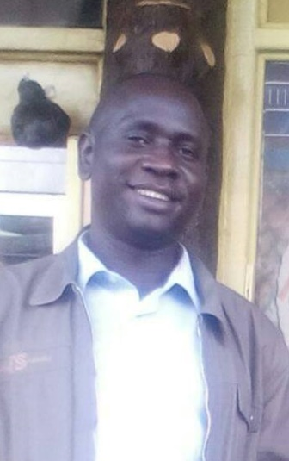Stanley is now our principal at Living Hope High School. He has traveled a long road with many impossible challenges to get here. God was with him!

He started out as a normal kid in the back woods of Africa. He is the oldest of 3 children. At school he was a good student, but getting sent home on a weekly basis was a challenge. There was never enough money for food and school fees. Many times he went hungry.

When Stanley was a senior in high school, his father died. Stanley thought that was the end of his education, but the head teacher came to his rescue and paid his way through graduation. He had nowhere to go and no way to make money to survive. His Uncle said that he could come and live with him and be his house boy.

Stanley had to take care of the cow, the garden, and the house. He had to cook for the family and get the kids off to school. They made him sleep out in the cow shed and eat the left overs (if there were any). So Stanley started to pray daily for some way for him to become a teacher. He knew that God’s plan for his life was to teach.

Stanley had been praying for six years when Mum Marilyn moved in next door. They became friends and she encouraged him to get information from the local teacher college. She said she would pay his first semester and after that God would have to take over. At the end of the semester, Helen, Marilyn’s sister took over and continued to support him for the next two years. Then an older couple from Faith UMC said they would sponsor him if he would be a pen pal to their disabled grandson. This worked well and Stanley graduated.

At Living Hope we needed a business teacher and we hired Stanley. He taught for two years and then our old principal died. Stanley to the rescue! He has been our principal for three years. He has handled almost every imaginable problem and is now a seasoned professional. (He is also a great artist!) God bless him

**Another Thank-You**

On behalf of Living Hope High School the students want to sincerely thank God for sending them a wonderful woman Gail Cox- Mission Team Volunteer. She has been a blessing to us in many ways.

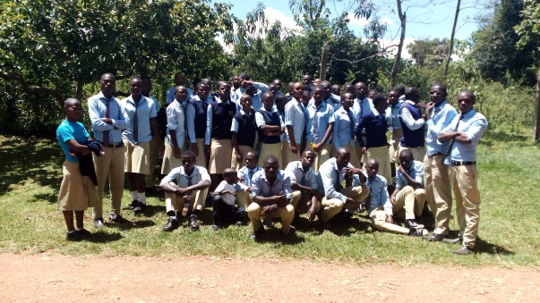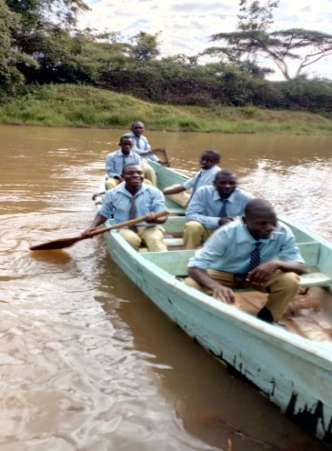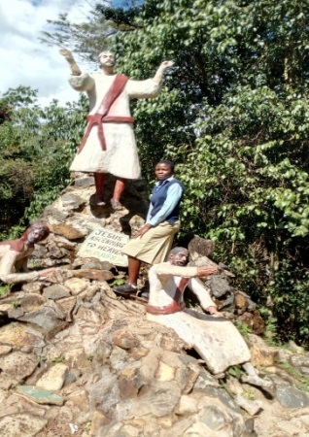On Oct 23rd she volunteered to sponsor all form threes and form fours and the students she sponsors, Isabella Simiyu, Evans Wasike, and Yvette Barasa to Kitale museum. All kids really enjoyed the trip since most of them had never been there before. May God continue to bless her and her family.

Student w/Statue of Jesus Students group photo at Saiwa Park Boating on artificial lake

**We Celebrate the Graduating Class of 2018 of Living Hope High School**

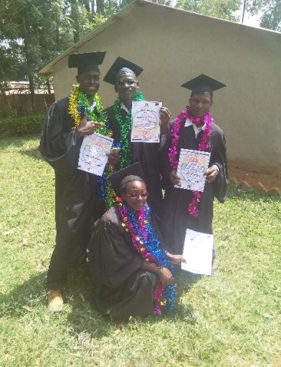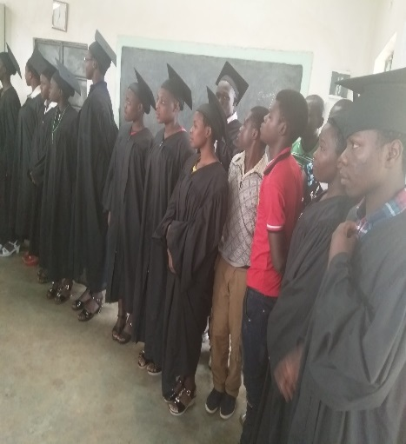The students had a day of joy and happiness as they get ready for a new season in their lives. They are so thankful and grateful for all who made their dreams come true on Graduation Day! Living Hope High School is one of the most sought after schools to get into in Bungoma County. We are so proud of the graduates.

LaVonne Pierson Hammett the U.S. Treasurer for LHHS gives all of the graduates a silver dollar.

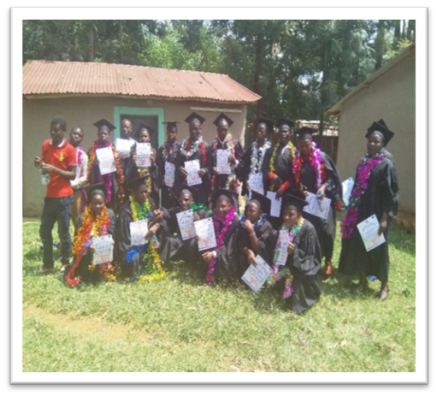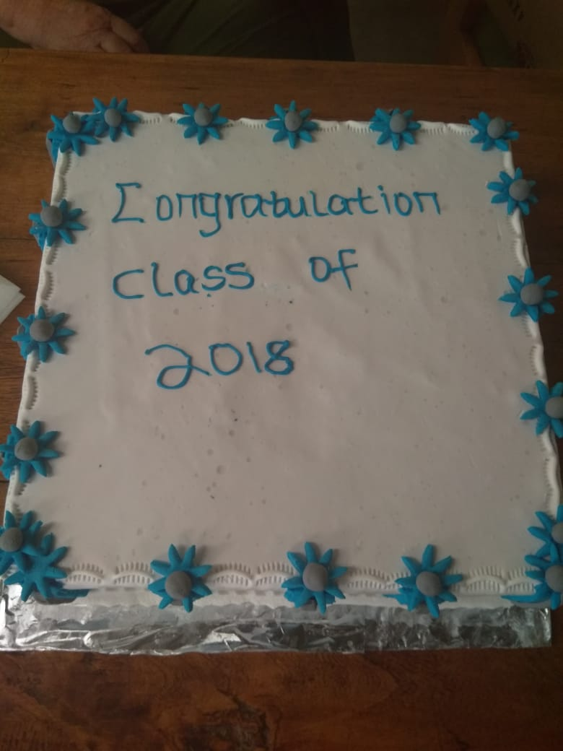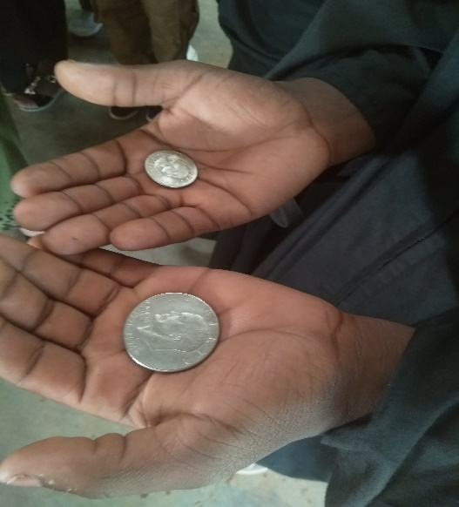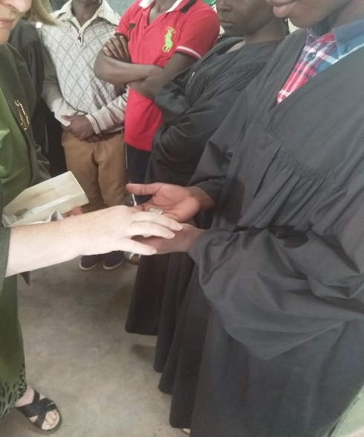That day was one they will never forget and then there was cake! God Bless them as they venture out into the world.

|  |  |
| --- | --- |
| 3 | Wamalwa Morphat B- |
| 7 | Joackim Khaweli |
| 1 | Masinde Abel |
| 2 | Kaburu Caleb |
| 4 | Were Emmanuel |
| 10 | Andrew Wangila |
| 9 | Teresa Mamai |
| 20 | Simiyu Madaline |
| 8 | Mukitang'a Sharon |
| 21 | Namasaka Daniel |
| 11 | Namalwa lavender |
| 18 | Nyongesa C.Fidelis |
| 6 | Khaemba Nesther |
| 12 | Munande Cynderella |
| 16 | Nyongesa Enos |
| 5 | Simiyu Margaret |
| 13 | Were Calvin |
| 17 | Imali Vivian |
| 14 | Simiyu Lucy |
| 15 | Winny Sinino |
| 19 | Wanyonyi Esther |

The list of graduates and the number corresponding on the left side by their name is **NOT** where they placed on their final exams. They are in order of how they did (top to bottom).

**Christmas is Nearing and the New Year Just Around the Corner**

Last year I was blessed along with some other team members to celebrate Christ’s birth in Kenya at Living Hope High School. It was a memory I will never forget. Dancing, singing, hearing the Christmas Story and having Communion with the students. We decorated a small Christmas tree with ornaments the students had made. On Christmas day a big food feast was prepared for the students. Their plates were piled high and one student told me “This is the best day of my life”, I pray we too can say the same thing this year.

As Christmas approaches let us not forget the real reason for Celebrating Christs birth!

Here are some things on the Christmas Wish list that the School needs.

* Funds for Mosquito Nets- $12.00 a piece
* Bibles in their Language- $8.00 a piece
* Funds for the Pavilion that the January team will be building

**Team Leaves for Kenya as the New Year Unfolds**

**Janaury 8-24, 2019** a team of ten, made up mostly from the West Virginia Conference will be departing for Living Hope High School. For some it will be a return trip and for others a new experience. Our schedule is full with construction, afternoon workshops, and evening bible studies on the parables along with visiting the Victory School nearby. Please keep the team in your prayers for their travel and health. We pray blessings for those we leave here in the US. As we journey please pray for the opportunity to share Jesus with those who we meet. Pray for our drivers who do a wonderful job and for those who serve us and for those unknown who we can serve.

If you would want to sponsor one of the children at Living Hope whether a student or a college graduate, it is one of the most wonderful things you can do. You can do it as an individual, a group or as a church! You will be blessed! Contact **Helen Markwell** for details. 304-567-2254

**Wishing everyone a very Merry Christmas and a Happy New Year!**

**Asanteni na Mungu awabariki wewe!**

**If you would like to donate to LHHS you can send your donation to:**

**Riverton UMC, P.O. Box 23, Riverton WV 26814**

**Please earmark it for what you are donating the funds to.**

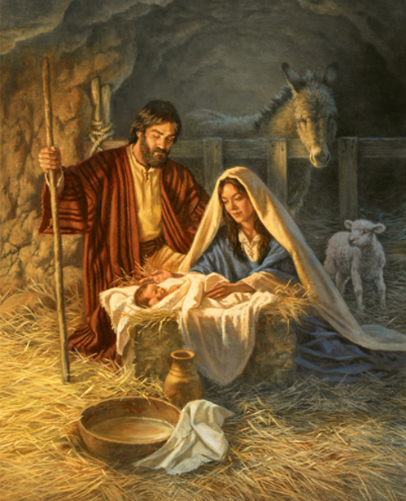

***”Who can add to Christmas? The perfect motive is that God so love the world. The perfect gift is that He gave His only Son. The only requirement is to believe in Him. The reward of faith is that you shall have everlasting life.” Corrie Ten Boon***

Sandy Binotto

WV Mission Team Coordinator/Newsletter Author

[Yashe4jc@hotmail.com](mailto:Yashe4jc@hotmail.com)

304-839-1505

Helen Markwell –

US coordinator

[helenum@spruceknob.net](mailto:helenum@spruceknob.net)

304-567-2254