

Living Hope High School

**P. O. Box 2376**

**Bungoma 50200,**

**Kenya-**

**Email: marilynkuhl59@gmail.com**

**info@livinghopehighschool.org**

**website:** [**www.livinghopehighschool.org**](http://www.livinghopehighschool.org)

**April/May –2018 Newsletter**

**Wanted Persons to Join a Mission Team to Living Hope High School**

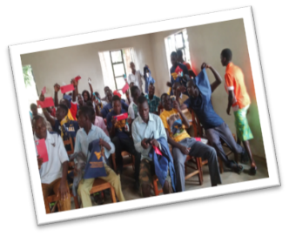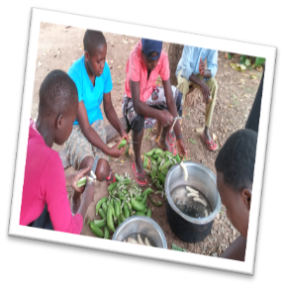

**Dates of Trip**

**August 21- September 5, 2018**

**Team return home September 6, 2018**

Project: Building a Pavilion to be used as an outside Learning Center, Beautification of School Grounds, Planting flowers, Garden Beds, Bible Study in evenings.

Estimated Cost: $2,500-$2,700

(Includes Safari and overnight at the Sopa Lodge in Nukuru on way home)

Team size is 9 (5 men, 4 women), No Youth under 18 unless parent is on team, 16-18yrs.

For information and team application, please contact Sandy Binotto: [yashe4jc@hotmail.com](mailto:yashe4jc@hotmail.com)

304-839-1505

Deadline for application is May 15, 2018

**"It is God to whom we travel, and while he is the end of our journey, he is also at every stopping place"**

**Donations Needed**

Donations are needed for the shipping of shoes and baby items taken to Living Hope on Marilyn’s last trip. There were soccer shoes that were misplaced and then found. Also there were much needed gym shoes. The youth needed them to wear as they play sports.

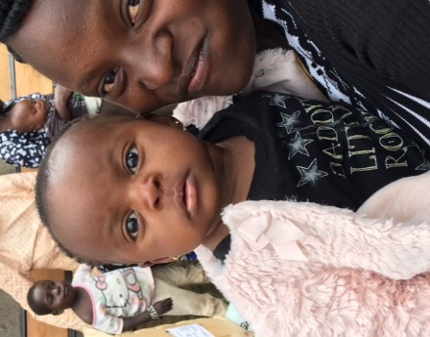Donations are also needed for the shipping of baby items taken for Nurse Catherine who runs an HIV Clinic. Pregnant mothers who are HIV Positive can be treated so their babies will be HIV Negative. Baby items are in such short supply and all the items they receive are so greatly appreciated. Nurse Catherine works every day at Living Hope High School, and at other times, delivers babies and works hard to help new mothers in her personal clinic. She is also a pastor, a woman of many talents.

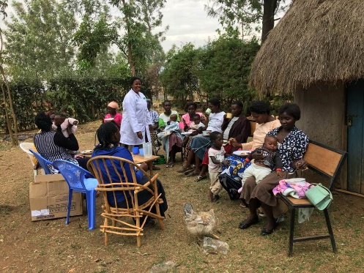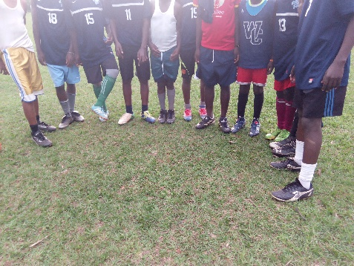

Spring Activities at Living Hope

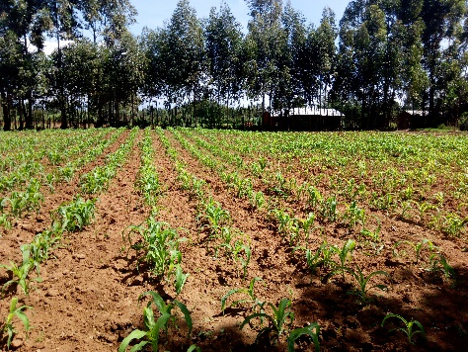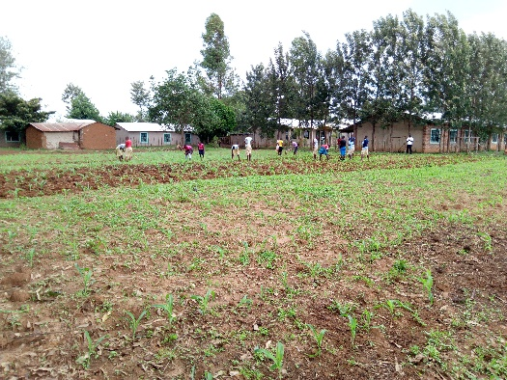

Working the soil and planting maze. Everyone works together to get the job done! Praying for a good harvest!

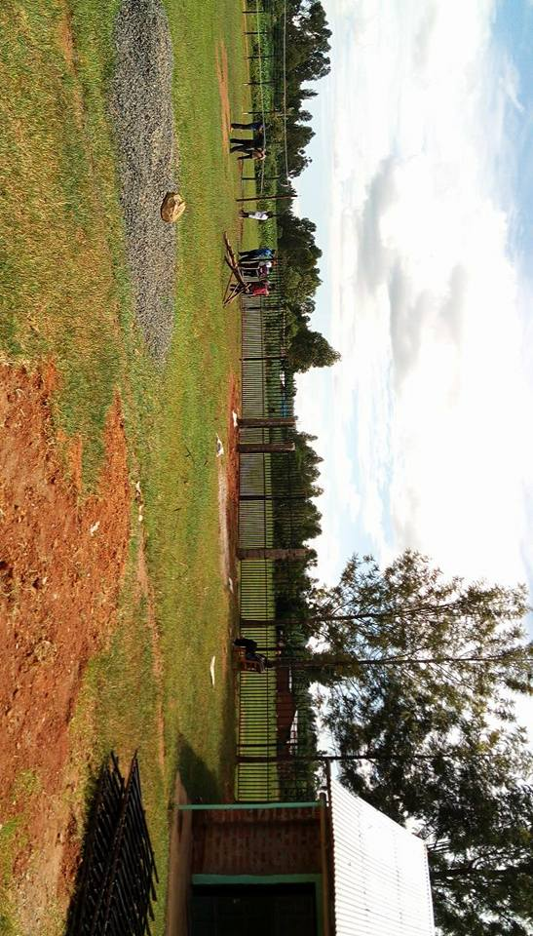

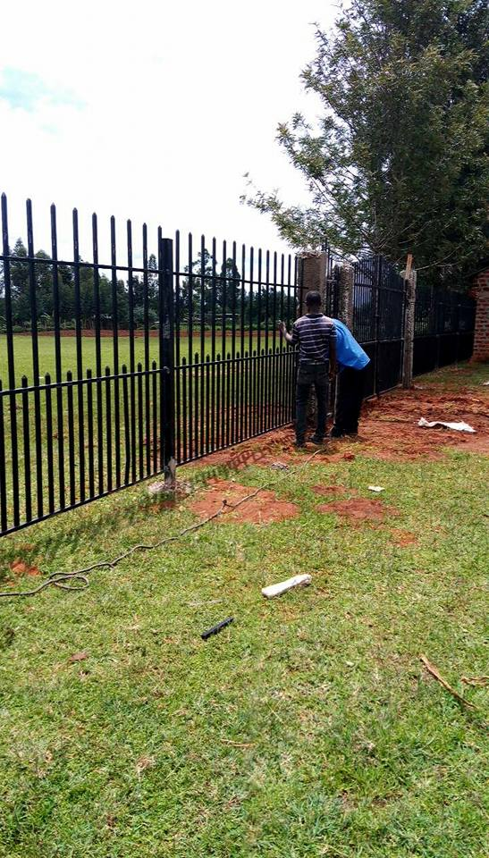A New Security Fence is being installed. We thank Connie Damon for her wonderful fund-raising skills and for all the donors who gave. This is another dream turned into a reality!

**Sponsors Still Needed**

We thank the Lord for all those who have committed to sponsor the new students and to those who continue to sponsor the other students. There are still 7 students who still need sponsorship. Also, we have 2 2017 graduates that have received partial government scholarships that are in need of some additional financial help. If you or your church or you as an individual would like to be a sponsor please contact **Helen Markwell** at: **304 567-2254** or email her at [helenum@spruceknob.net](mailto:helenum@spruceknob.net).

We would also like to thank the UMW of the Potomac Highlands District for their sponsorship for Linette Wekesa.

**Meaning of Sponsorship: Someone who supports or champions something.**

**Mum Marilyn travels again soon**

Please be in prayer for Mum Marilyn as she travels to the US later this month. She’ll be here to attend the WV Annual Conference where Living Hope High School will be sponsoring a Kenyan breakfast. She will be arriving back on May 24, and will be traveling with one of the students, Naphtal Sikuku. Naphtal will be visiting America for the first time, and has been chosen to work at a special needs camp in Pennsylvania for the summer. He is one bright student who grew up at Living Hope High School and is currently in college studying Special Education. While at Living Hope, he took good care of the livestock and made sure they were fed and healthy. I know it is a dream come true for him to visit America!

Our Kenyan breakfast will be a time for you to experience the small, yet delicious breakfast the students at LHHS have every day. It will be on Friday, June 8th at 7:30 in the upper level of the chapel in the “chambers”. See you there!

**Student Story**

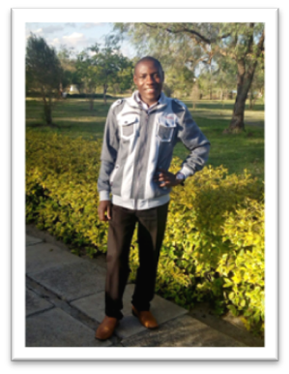

**Joel Masinde** was born in1997 in a family of eleven children; nine brothers and one sister. Both of his parents are alive.

Joel started his education in 2001 at Sikalame Primary School where he was enrolled in nursery school. He continued with his studies until he finished class 8. Masinde passed very well and joined Kuywa Secondary School for his high school education.

At Kuywa High School, Joel was not concentrating in class. He was sent home for fees often. His parents were not able to pay for his fees on time. This was big challenge to Joel. He had a passion for education since he believed and still believes that it is the key to success.

In 2014, Joel heard about Living Hope High School from Mark Mumali, a prior LHHS graduate, whom is now studying medicine in college. Masinde applied to Living Hope High School. He was accepted despite stiff competition from 185 applicants. He was enrolled in form three and since then his story has changed. Praise God!

Joel worked very hard at Living Hope. He passed all his exams well and sat for Kenya Certificate of Secondary Education in 2015. He got a B- , which was a university entry mark.

Joel then joined East African University where he is pursuing a Bachelor of Education (Geography and Business Studies). On campus, Joel has kept the candle burning by working very hard. In the first semester, he scored 3 A’s and a five B’s. This semester, he is hoping to get all A’s! He can be described as an eager learner, and an astute and able student.

Joel acknowledges Living Hope High School as the source of his continuing success. He thanks Mum Marilyn Uhl and the school fraternity for their support in his life. More importantly he would like to thank his sponsors, Carol and Bill Bowen, for their continued love and support. Joel knows that God was behind it all!

Joel is a saved Christian. When he joined East African University, there were almost 400 students. The owner of the campus is a Muslim and the campus at that time was dominated by Muslim students. This was the first year that the government sent direct entry students to East African University. Joel joined with other Christians to start their own Christian Union Society within the institution. Almost three quarters of the students in the campus joined in the Society. The society is growing each and every day. Joel is the new vice chairman of a 700 member Christian Union. He is so grateful that students are willing to serve their Lord Jesus Christ. They have a strong praise and worship team, ushers, and intercessory prayer teams. They do their best to give God adoration and praise, since He is worthy.

Joel really thanks God for the opportunity for church leadership. He is willing to serve and use his God given talents to help the students. He prays that God will give him knowledge and wisdom as he leads His people. The society conducted their first evangelism crusade while on campus on April 27, 2017. 92 people gave their life to Christ. Many of them were previously Muslims!

In addition, Joel and his CU members have been visiting orphanages near the university. The members interact with the kids and share with them about some of their life encounters and encourage them to work towards their goals. He reports the kids are bright with great ambitions to be achieved.

Joel aspires to be a lecturer at a university in future. He has a plan to pursue a Master’s Degree in Geography. We, associated with Living Hope, believe that with his determination and strong faith, God will make it happen.

**Speakers**

If you are looking for a mission speaker for your church/women’s groups or youth group, please consider someone who has traveled to Living Hope High School. It is a ministry that is doing well and sharing the Love of Jesus to all who step foot on the grounds of the school. Living Hope is a WV Conference Ministry and Advance Special. Call Helen Markwell for an available speaker near you.304-567-2254

Living Hope is also looking for persons/couples who are interested in serving for more than two weeks. There is special Mission Training if you feel called to share your gifts and talents at Living Hope for the long term. You may also contact Sandy Binotto (304-839-1505, [yashe4jc@hotmail.com](mailto:yashe4jc@hotmail.com)) for more information about traveling there and what would be needed.



**JUST A REMINDER**: Sponsors, please send a note now and then to your student. You will never know how much this means to them.