September 2017 Newsletter

**Update on Mum Marilyn**

**Living Hope High School**

P.O. Box 2376

Bungoma, Kenya- 50200

Email: [marilynkuh59@gmail.com](mailto:marilynkuh59@gmail.com)

[Info@livinghopehighschool.org](mailto:Info@livinghopehighschool.org)

Website: www.livinghopehighschool.org

Facebook page: Living Hope High School



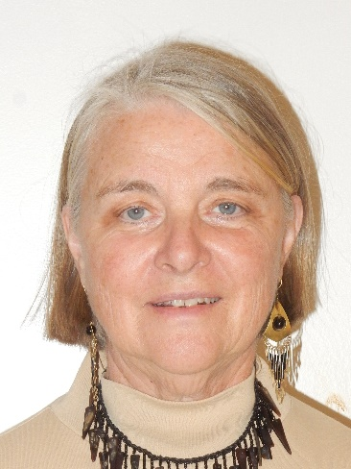Many have asked about how Mum Marilyn is as she is referred to in Kenya. She still continues to do her daily routine but with challenges of still being dizzy. Something that has not gone away. Please continue to pray for her and her health. She will be returning to the states this fall for further testing and to hopefully find out what is causing the dizziness.

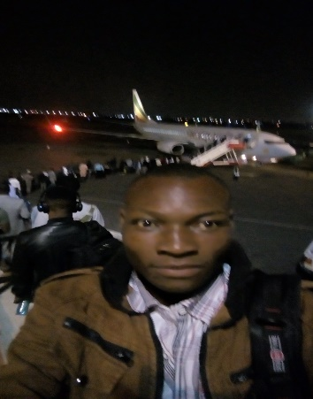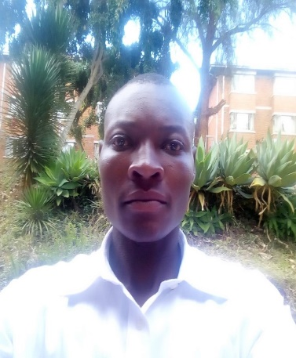Please lift her up with an email, letter or note of encouragement. Her address, email listed above.

**Many Thanks!**

Many thanks goes out to the West Virginia Conference, sponsors and donors who have stepped up to the plate with loving and giving hearts who have helped

sponsor graduating students from Living Hope High School. A big thank you goes to Bishop Sandra Steiner-Ball and J.F. Lacaria and others who helped one of the students be accepted into the **Africa University** who will have a full paid scholarship. Rogers Wabwile had quite the journey from Kenya to Zimbabwe. He was accompanied by Muruga Josephat another graduate who saw him safely to the Africa University. Roger’s had never been on a plane and his joy was overflowing for such a dream as this to come true. He has settled in nicely and is doing well and so thankful for this opportunity which only came about by all of you.

**Roger’s getting ready to board his plane and all settled into the Africa University. One happy Living Hope Graduate!**

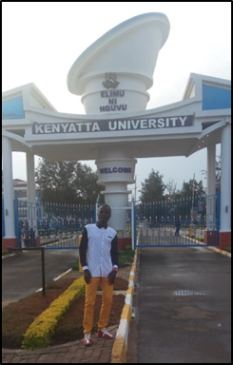Other students have also graduated and stepped into college life. Several still need some sponsor support to help them. One of the Students, Samuel Wekesa who scored the highest grades at the school in his graduating class still needs some help for his cost for his college tuition. It would be sad for this young man to not be able to get where God wants him to go because of his lack of funding. Any help would be greatly appreciated!

**Dr. Virginia Rae**

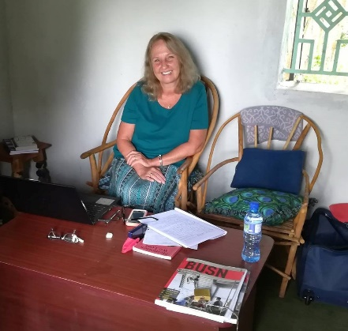The School was honored to have Dr. Virginia Rae from Eastern Mennonite Seminary and an adjunct professor at Lord Fairfax Community College, with them for six weeks. While at Living Hope High School she taught several business classes to the students using her curriculum along with Kenyan business requirements. She did a great job and the students loved the exciting presentations she brought to her lessons. Thank you Dr. Virginia and God bless you for traveling to Living Hope High School to share your gifts and talents!

If you are interested in giving some time and love to these students as a short

term/long term volunteer, please contact Mum Marilyn, Helen Markwell or Sandy Binotto.

**HGTV (remodeling and updating) at Living Hope High School**

Much new and remodeling work is being done at Living Hope. New Latrines are being built, chickens are getting a new home. New security fence and lights are being installed. A recent U.S. yard sale generated funds to help with purchasing some fire equipment and fire training with an escape plan and much more.

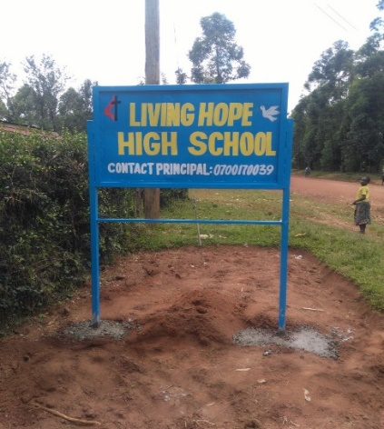

New Living Hope High School

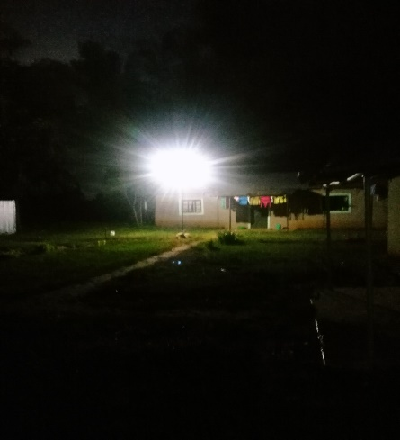Sign

New Security lights at cottages.

New Chicken House

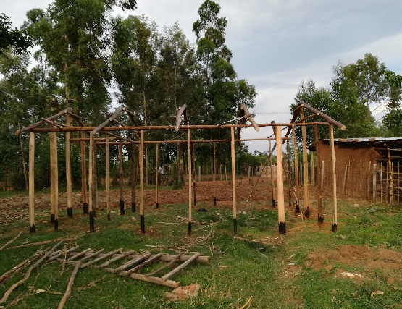

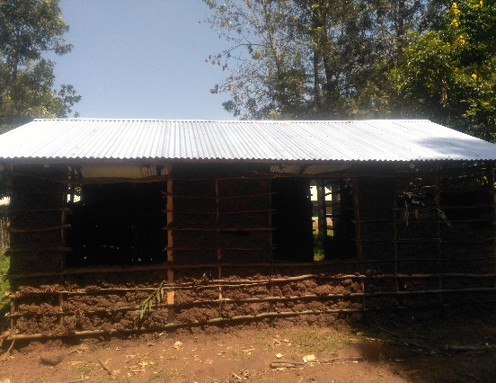

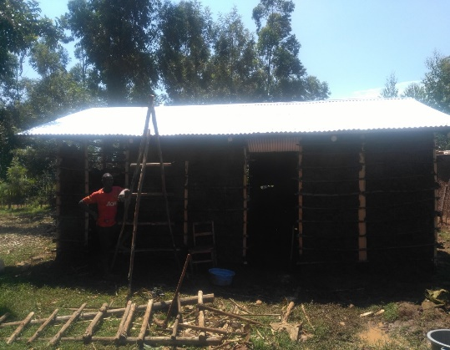

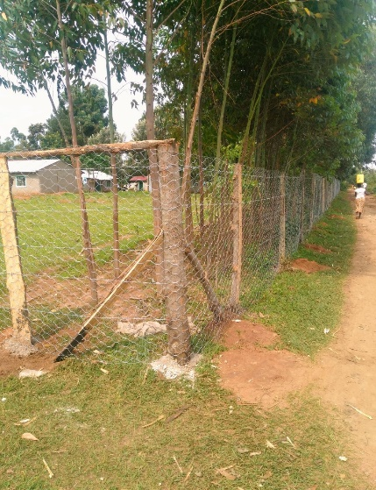

New border fence is being constructed around the School.

New Latrines being built.

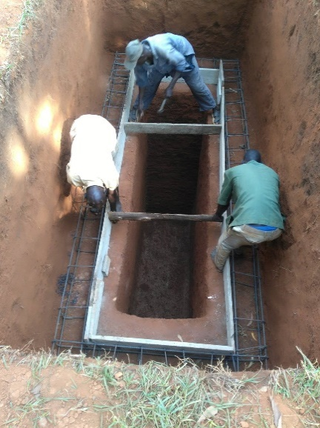

Kitchen gets new floor and remodel of cooking stoves, Kenya style

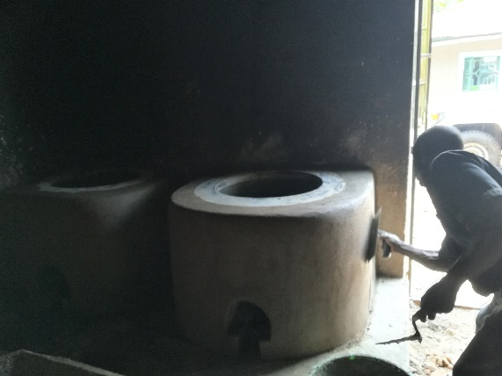

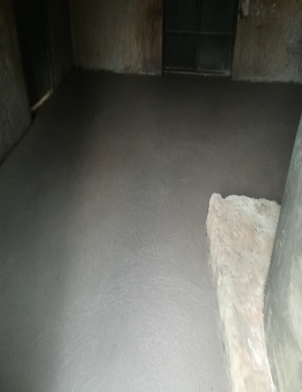

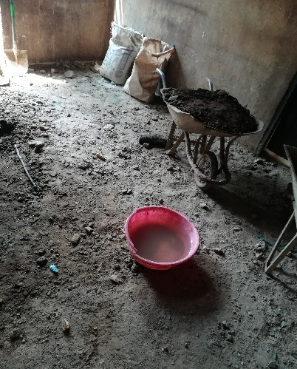

Before After

I know NEW was mentioned many times and that is what is happening. A wonderful New spirit of Hope and Joy is arising at Living Hope. The students are working very hard to make their school one of the best in Kenya. They stand united in Christ and are proud of their accomplishments with your help and all of great things that have been done. Many God fearing, loving, smart and talented students are graduating from this wonderful school who otherwise wouldn’t have gone very far. They are family!

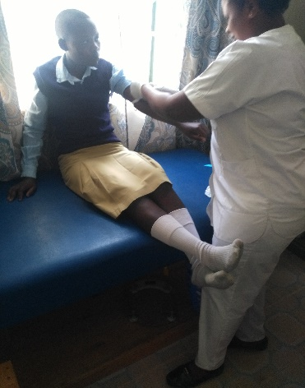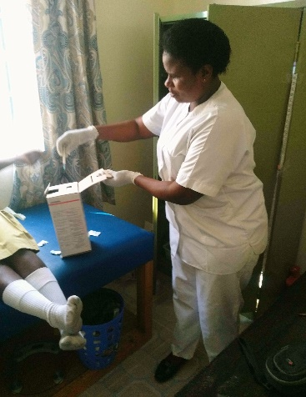Living Hope is also very blessed to have a wonderful nurse Catherine Nelima who takes great care of the students, staff and Mum Marilyn. She works several days a week at the school in the Clinic.

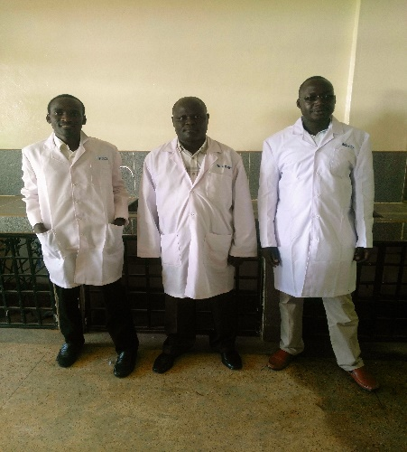The School is very fortunate to have a Science Lab. Pictured below from Left to Right are some of the teachers. Masinde Yohana, physics teacher, Fleix Bukhebi, biology

teacher and Paul Mbaya Chemistry teacher.

The School is also proud of its Christian Union Group. It is to

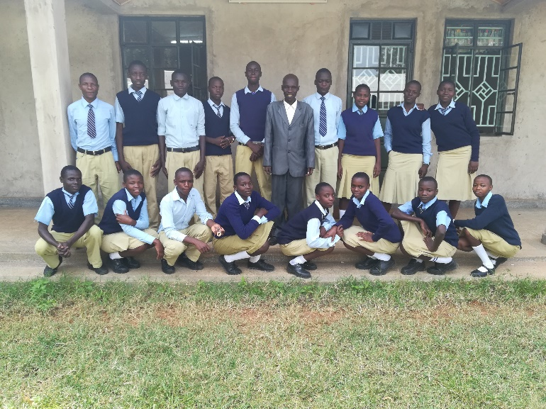to run a golden thread that every believer can connect with to add their voice to a movement for continental transformation. *Do you see one of your* *students in the picture?*

Back Row from Left to Right:

 Enos- C. U chairperson (C. U Pastor), Dynatias- Intercessory leader in charge of prayers in school, Morphat - Praise and worship leader in charge of singing, Caleb - C. U secretary, Joakim - C. U organizing secretary for Christian union's activities, Abel- Form 3 Class Pastor in charge of the spiritual matters of the class, Margaret -  C. U treasurer keeping the financial records of the Union, Sharon - Usher during Sundays and on other school functions and lastly is Elizabeth - Deputy Chairperson (mentored to take over when the current chairperson reaches form four)

 FRONT ROW: Left to Right

 Joseph-form one class pastor, Joan- Usher, Meshack- Usher, Carolyn -  Form one class pastor, Shalom - Prayer House caretaker, Georgina - Bible study Coordinator ( coordinating Bible study activities), Anna - Prayer House Caretaker(Cleaning the prayer and keeping it in good shape all the time) and finally Lavender -  Form 2 class pastor.

 With them is the Patron, Mr/Reverend Gabriel Wafula who oversees their activities and gives them the necessary guidance in the duties.

Each Newsletter will now contain a story of one of the Students. This Month’s story highlights Joel Masinde

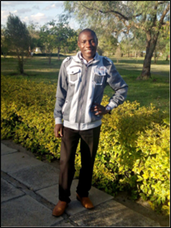Joel Masinde was born in1997 in a family of eleven children; nine brothers and one sister. Both of his parents are alive.

Joel started his education in 2001 at Sikalame Primary School where he was enrolled in nursery school. He continued with his studies until he finished class 8. Masinde passed very well and joined Kuywa Secondary School for his high school education. At Kuywa High School, Joel was not concentrating in class. He was sent home for fees often. His parents were not able to pay for his fees on time. This was big challenge to Joel. He had a passion for education since he believed and still believes that it is the key to success.

In 2014, Joel heard about Living Hope High School from Mark Mumali( Mark was a student of Living Hope High School). Masinde applied to Living Hope High School. He was accepted despite stiff competition from 185 applicants. He was enrolled in form three and since then his story changed. Praise God! Joel worked very hard at Living Hope. He passed all his exams well and sat for Kenya Certificate of Secondary Education in 2015. He got a B- , which was a university entry mark.

Masinde then joined East African University where he is pursuing a Bachelor of Education (Geography and Business Studies). On campus, Joel has kept the candle burning by working very hard. In the first semester, he scored 3 A’s and a five B’s. This semester, he is hoping to get all A’s! Masinde can be described as an early learner, astute and able student.

Joel Masinde acknowledges Living Hope High School as source of his continuing success. He thanks Mum Marilyn Uhl and the school fraternity for their support in his life. More

importantly he would like to thank his sponsors, Carol and Bill Bowen, for their continued love and support. Joel knows that God was behind it all!

Joel is a saved Christian. When he joined East African University, there were almost 400

students. The owner of the campus is a Muslim and the campus at that time was dominated by Muslim students. This was the first year that the government sent direct entry students to East African University. Joel joined with other Christians to start their own Christian Union Society within the institution. Almost three quarters of the students in the campus joined in the Society. The society is growing each and every day. Joel is the vice chairman of a 700 member Christian Union. He is much grateful that students are willing to serve their Lord Jesus Christ. They have a strong praise and worship team, ushers and intercessory prayer teams. They do their best to give God adoration and praise, since He is worthy.

Joel really thanks God for the opportunity for church leadership. He is willing to serve and use his God given talents to help the students. He prays that God will give him knowledge and wisdom as he leads His people.

They conducted their first mission while on campus on April 27, 2017. It was great to see how people were willing to receive Christ as their savior. 92 people gave their life to Christ. Many of them were Muslims!

In addition, Joel and his CU members have been visiting orphanages around the campus. They interact with the kids and share with them about some of our life encounters and encourage them to work towards their goals. He cites that the kids are bright with great ambitions to be achieved.

Joel aspires to be a lecturer at a university in future. He has a plan to pursue a Master’s Degree in geography. We as Living Hope believe that with his determination he will make it.

**Prayer Concerns for Living Hope High School**

* Mum Marilyn’s health. She is healed of her dizziness.
* The **October 17th**, election for President in Kenya. Pray for a peaceful election.
* Daily activities at Living Hope. Continued funding for the school to keep it running well.
* Health of the students, and staff.
* Future VIM teams that are making plans to visit Living Hope High School.

December 2017 team from Avery UMC, Morgantown, WV who are planning to build a foot bridge near the school for the community as well as doing activities at the school.

If you would like to help sponsor a student, help with college tuition or go as an Individual Volunteer or lead a VIM team you may contact:

**Helen Markwell**

P.O. Box 15

Seneca Rocks

WV. 26884

304-567-2254

helenum@spruceknob.net

**Sandy Binotto**

P.O. Box 478

Augusta, WV, 26704

304-839-1505

[Yashe4jc@hotmail.com](mailto:Yashe4jc@hotmail.com)

Helen and Sandy and others are also more than happy to come and share about Living Hope High School. Please contact them if interested.

The Living Hope Newsletter has now been transferred over from Helen Markwell to Sandy Binotto who will be putting it out monthly. It is a pleasure and joy to hear and see how the Lord is working through his people and connecting us all together with this great ministry at Living Hope High School.

“Let us travel on together with the Lord”

I leave you with this Kenyan Proverb:

A flea can trouble a lion more than the lion can harm a flea.

